Game Design Document Try-Guys

|  |  |  |  |
| --- | --- | --- | --- |
| Document and Project Revision List | | | |
| Version | Author | Date | Comments |
| 0.1 | Thomas Riches | 24/09/2019 | Draft document |
| 0.2 | Tembani Mdaya | 03/02/2020 | Added some text and images. |

Table of Contents

Introduction 2

Refrences 2

Platform and Software 2

Game Specification 2

Game Concept 3

Story/setting 5

Game Features 5

objective 5

Graphics 5

Gameplay 5

overview 5

Controls 5

Map Design 5

flowchart 6

Interface 8

Menu 8

Hud 8

camera 8

Team 8

Appendices 8

Ammendments 8

asset list 8

# Introduction

The game we are going to create is a first-person platformer. The game is set in a post-apocalyptic wasteland where they find themselves stranded in a gorge. The player must make use of free-running abilities and a grappling look

The game will incorporate elements similar to games like Mirror’s Edge and Titanfall 2.

## Refrences

[(cargo ship)](https://image.shutterstock.com/z/stock-photo-cargo-ship-covered-with-rust-on-a-beach-near-gythio-greece-238115122.jpg)

<https://github.com/Tri-Guys>

# Platform and Software

The game will be developed for use with either a keyboard or a controller on Windows, but could be made to work for mobiles and tablets. The game will be developed in the Unity game engine using a 2.5D environment as the team has more experience with Unity than the Unreal Engine.

# Game Specification

## Game Concept

The game is inspired by a few gameplay concepts found in titles released in the last decade and a half.

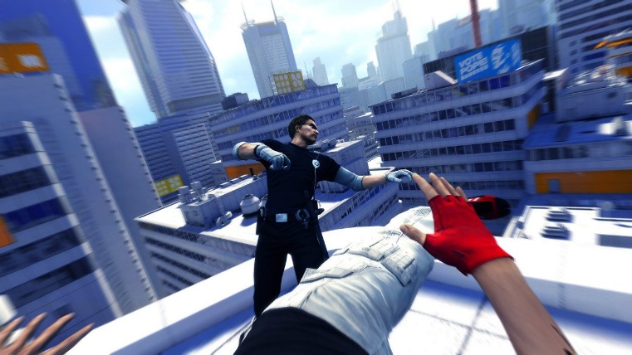

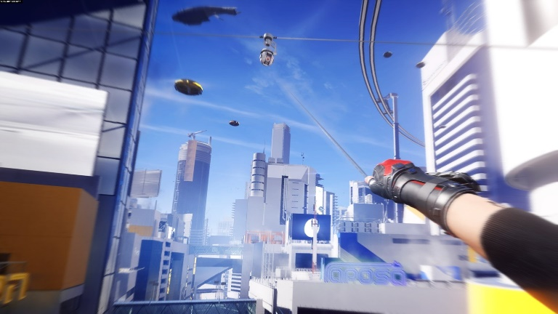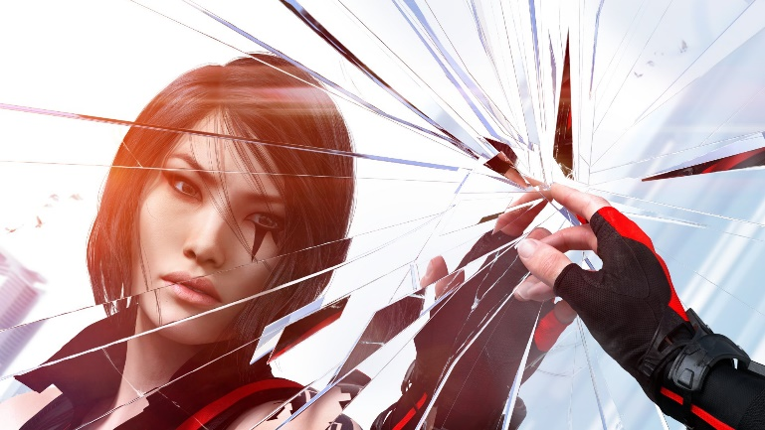

**Mirror’s Edge** is a first-person free-running game developed by DICE and released by Electronic Arts in 2008. It subverted expectations of the public by having a focus on avoiding combat and accumulating speed to cross traditionally out-of-reach areas in first-person perspective games. The protagonist Faith Connors, a Runner who delivers mail outside the dystopic government’s reach and control, is capable to hand-to-hand combat, disarming opponents and utilising their weapons against themselves. But several key factors such as the weapon’s weight limiting Faith’s speed, her fragility when face-to-face with several gunmen, her inability to see the rounds left in the magazine and reload the weaponry pushes the player to either work around and pick off enemies one by one, or completely avoid conflict altogether. In the hands of a good player Faith can become a human missile, picking up speed, bouncing off walls and delivering high speed kicks.

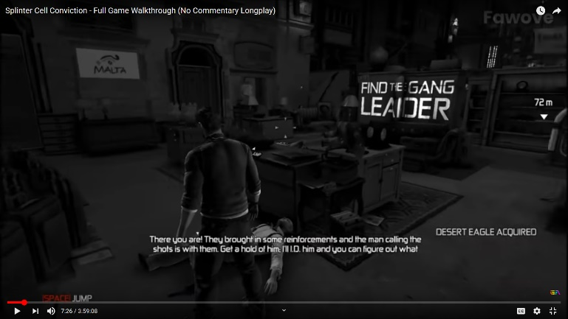In 2016 a re-sequel called **Mirror’s Edge: Catalyst** was released, resetting the story and locking most of Faith’s abilities behind a skill tree. With enough effort the player can unlock and gain back key parts of Faith’s repertoire such as safety rolls for making safer landings. Additionally she can gain access to a piece of equipment similar to a grappling hook, allowing her to zip herself up onto certain high ledges or grab onto nearby drones to cross large gaps.

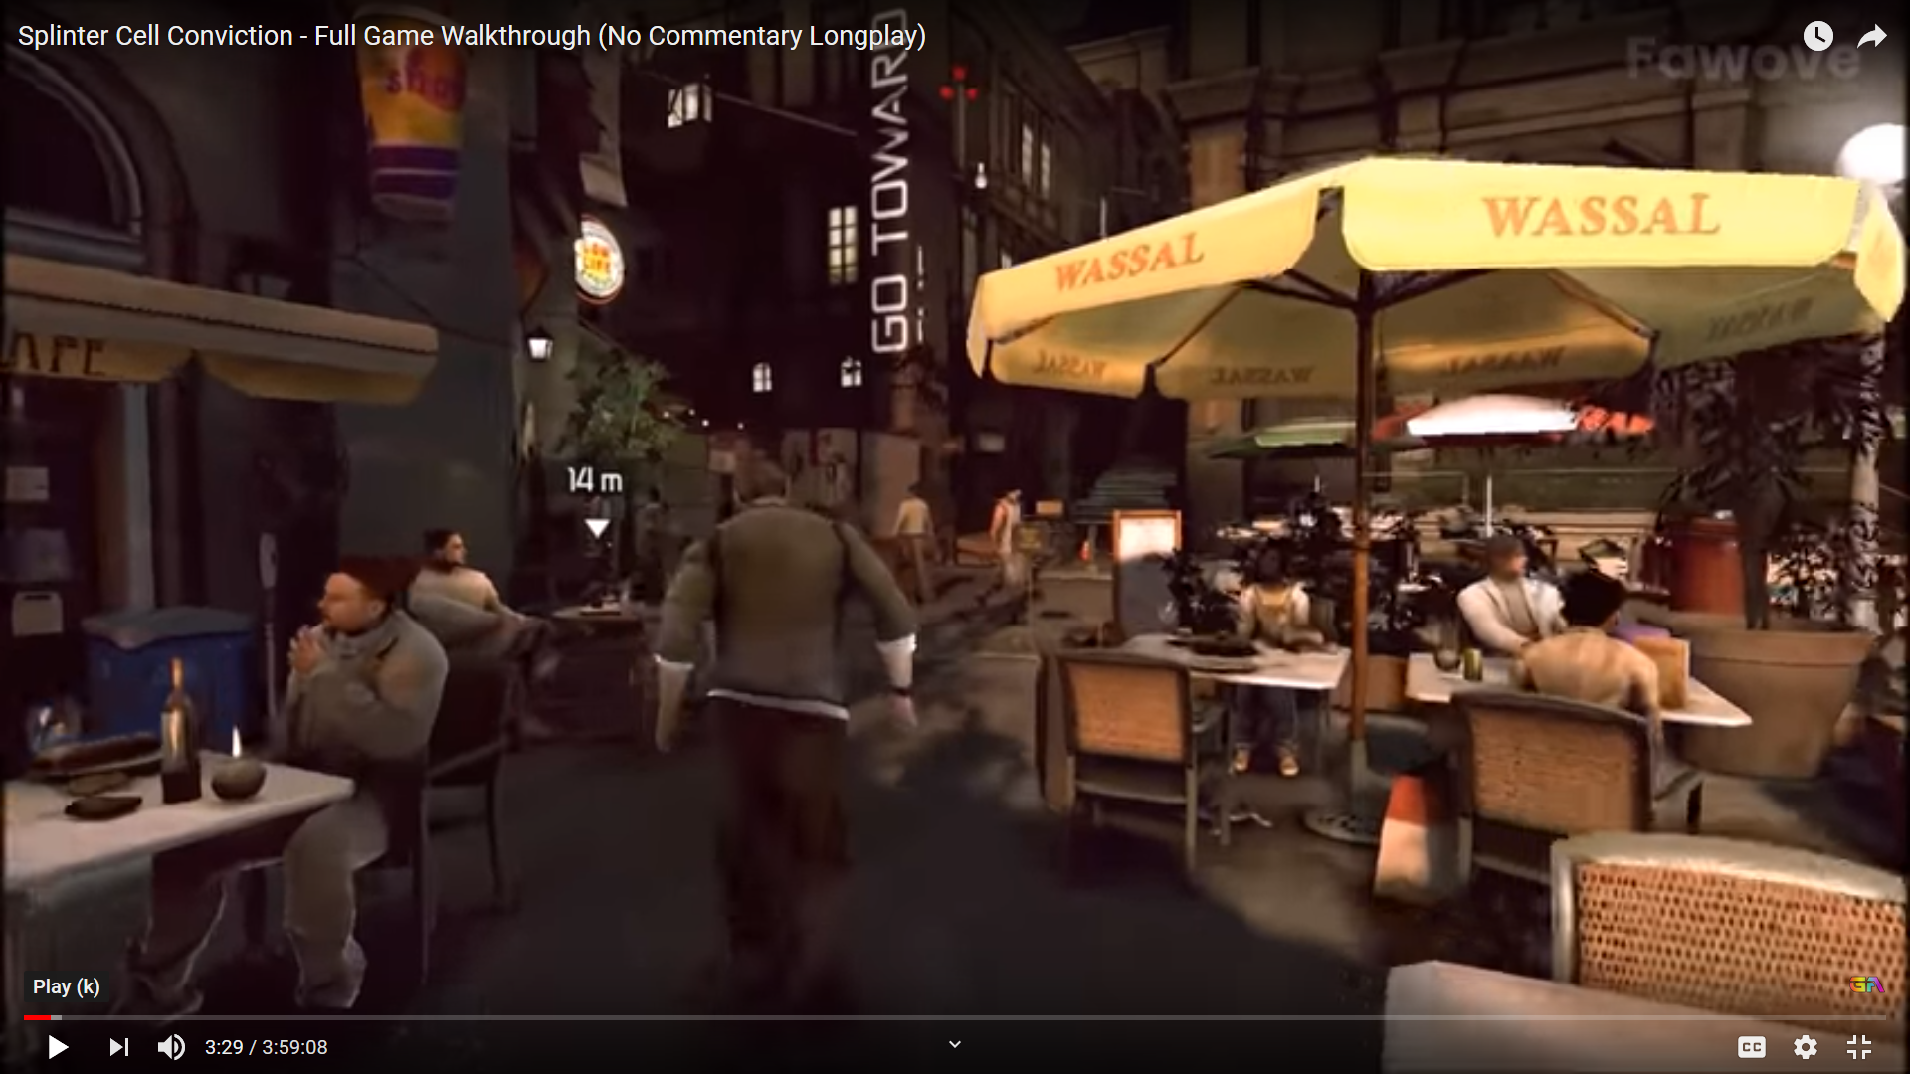

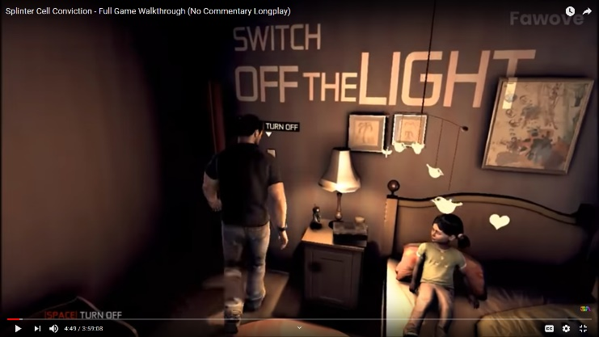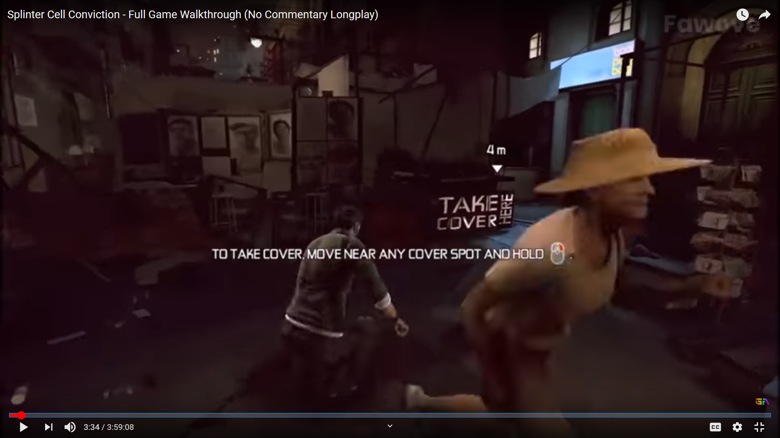

In Ubisoft's **Splinter Cell Conviction**, a new visual hint system was introduced as part of the instalment's new art design. At the beginning of every major story event and after each major cutscene the player's camera would return to its default position behind series protagonist Sam Fisher, a rogue Third Echelon agent, before drawing Sam's current objective on a surface in the player's field of view.

This new system takes the place of the franchise's previous method of displaying the objective through the heads-up-display by drawing the works. The method used to display the words is more than an environmental effect: should Sam attempt to stand in front of the guide the words will be drawn on him as if standing in front of a projector. This same effect is also used at crucial points in the story, displaying flashback moments on both the walls and key actors as if they're standing in front of a physical projector.

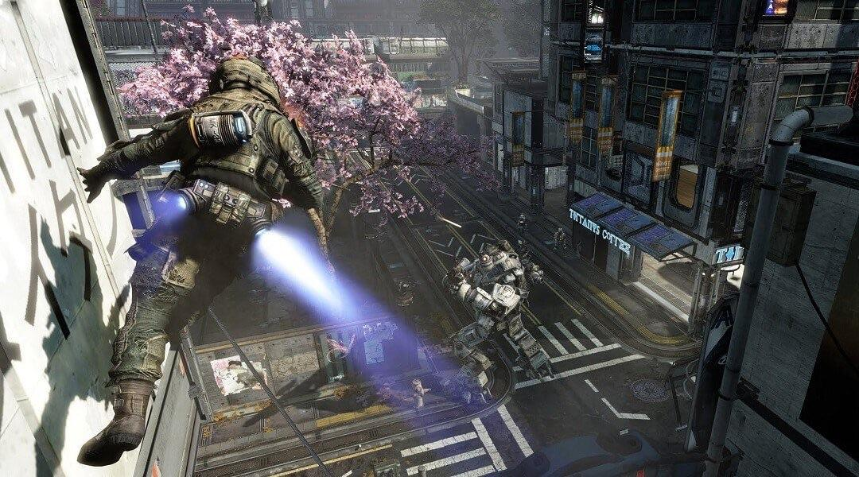

Respawn Entertainment's **Titanfall** was a 2014 multiplayer-only title which pitted two teams of highly agile players dubbed Pilots against one another, in a map packed with cannon fodder AI infantry set up for slaughter. The key game-mode Attrition is a spin on the traditional Team Deathmatch found in shooters: players choose a loadout for their Pilot

However, the main marketing point for Titanfall was its titular Titans. When a special meter was filled, either by waiting or speeding it up by landing successful kills, Pilots could commence Titanfall and call in a personal walking talking death machine dubbed a Titan. They could either walk around shooting opponents or operating on their own AI, or the player could personally embark and control them using them to empower themselves. Titans added a second dimension to the player-versus-player element as Titans could allow players to start shifting the tide of battle. They were giant lingering threats to now smaller opposing Pilots, an even match for evenly sized opposing Pilot-controlled Titans but were still out-classed and even threatened by nimble Pilots.

Titanfall 2 carries over the multiplayer and core gameplay of its predecessor while adding many new features. The tight free running movement, which combines wall running with a double jump, has been augmented with an always-available slide for crouching while sprinting. In the revised multiplayer and the brand-new single-player, the player can equip the ability to launch a flexible temporary grappling hook. Simply attaching hook onto a surface will pull the player towards it but holding a direction will allow you to swing with momentum.

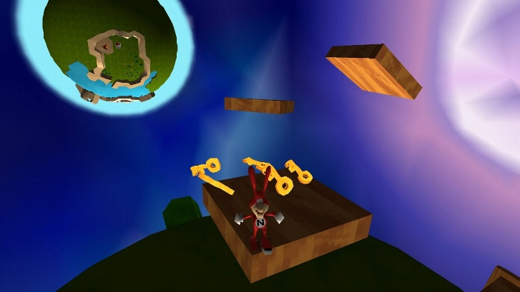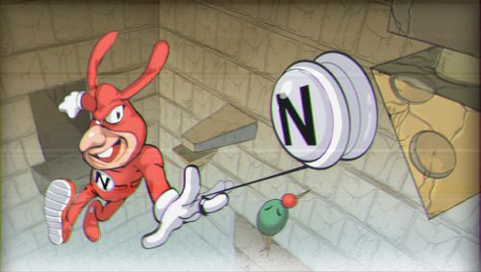

Similarly, the fan game Yo Noid! 2 which features the retired Dominos mascot The Noid also features a grappling hook mechanic in the form of The Noid's yo-yo. There are key perches, poles and containers The Noid can grab onto with the yo-yo to pull, open and even swing from. Additionally, The Noid himself can wall run for a short distance and wall jump, allowing similar chaining of mobility moves and increased agility.

## Story/setting

Some amount of time has passed since the bombs have dropped. World War III has felt the world outside

You are a downed pilot. In the event of your aircraft, a contingency in the form of training and mastery of a grappling hook was put in place. You must make use of your training and equipment to scale desolate buildings and clear bottomless caverns to escape the gorge.

Welcome to the Wastelands.

## Game Features

The player will be armed with enhanced mobility compared to other games, coming out of the gate with a double jump and the ability to run and jump off walls.

In place of a weapon the player will have access to a grappling hook utility. The hook works within a set distance, but once it catches onto a desired surface it will not disengage without the player’s input.  
  
The Hook will attach to distinct black obsidian rocks that are attached to some of the walls of the buildings in the game.

## objective

The player has one objective: escape. Every area has a solution.

## Graphics

The game will be from a first-person perspective, to help immerse the player and allow them to judge depth better.

# Gameplay

## overview

The gameplay will involve the player utilising their abilities to make sense of several cave-themed climbing frames, tasking them with completing them and rewarding them with harder climbing puzzles.

## Controls

The player will use the WASD keys to move around the play space, the space bar is used to jump, the mouse is used to look and the left mouse button will be used to shoot and disengage your hook.

## Map Design

Some amount of time has passed since the bombs have dropped. World War III has felt the world outside

You are a downed pilot. In the event of your aircraft, a contingency in the form of training and mastery of a grappling hook was put in place. You must make use of your training and equipment to scale desolate buildings and clear bottomless caverns to escape the gorge.

Welcome to the Wastelands.  
  
Starting off at a canyon, in between long narrow path to introduce movement controls.   
The controls will be shown displayed on the walls but in a way that fits in with the world (no signposts).  
Afterwards, the space will get bigger to allow more freedom in movement/practising what you learned while also demonstrating new movement controls.

Afterwards, the player will go to the next area but the ground/area will crumble and fall and time will slow down to show the player the grapple hook and where to use it.  
(to help subvert expectations making the level a little more memorable)

And then this will have the player be put into a big area that will have a visible end goal but no instructions on how to get there. To engage the player in using the knowledge they gained beforehand and do some thinking.

The design of the map resembles a destroyed ship port made into a cobbled together arena made from bits of rusted scrap, cargo containers and cargo ship with the remains of the cargo ship still in its port. We decided on this design as it reinforces the post-apocalyptic setting the game takes place in. This also allows us to scatter obstacles throughout the arena to give the player some difficulty navigating the map and to enforce the aesthetic of the ship being picked apart for parts.

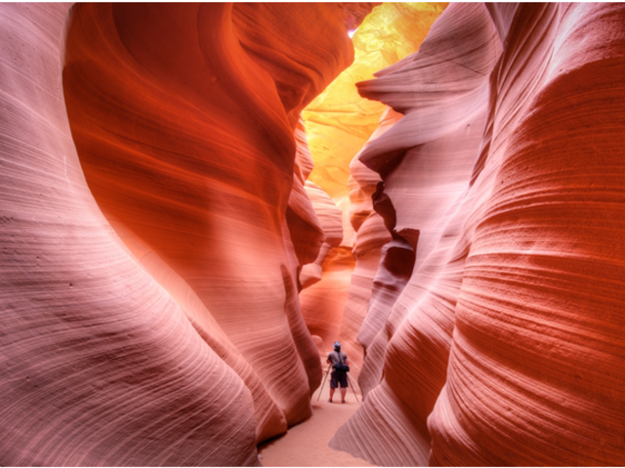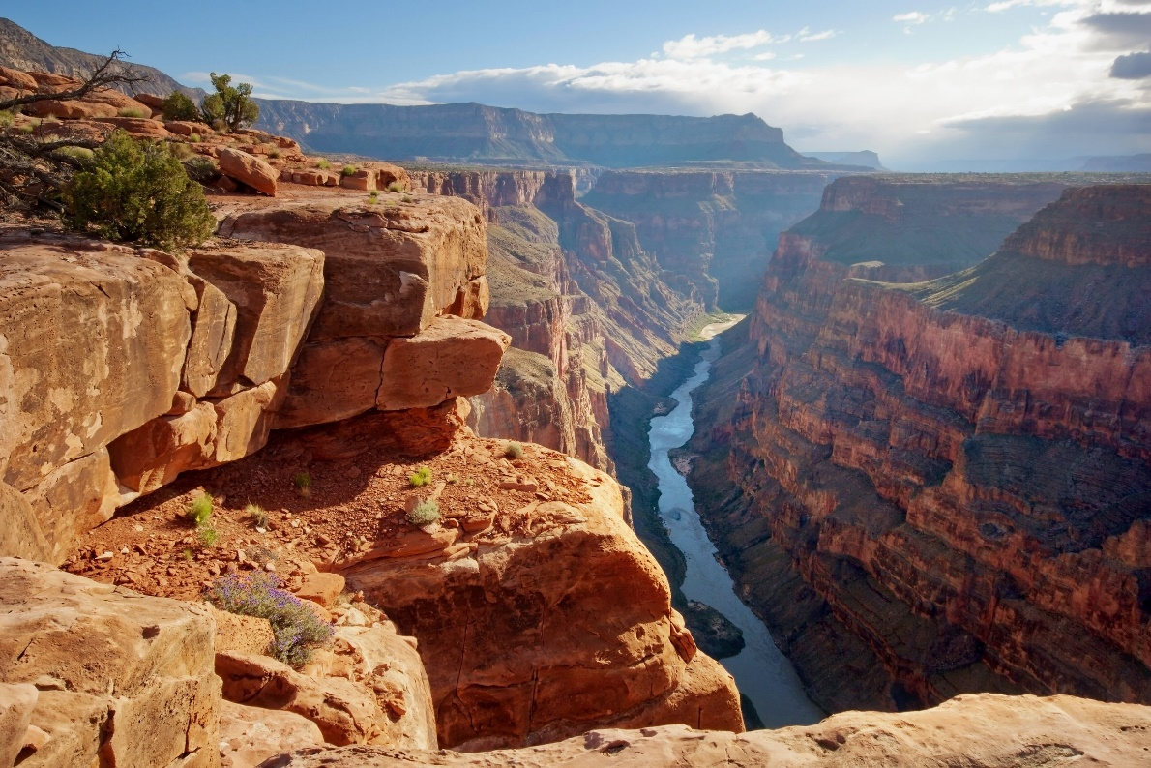 



## flowchart

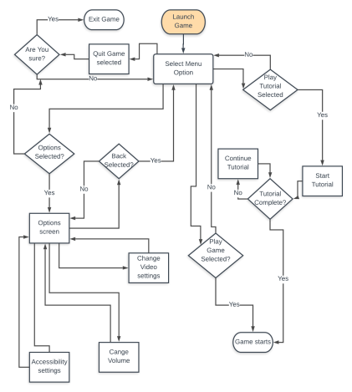

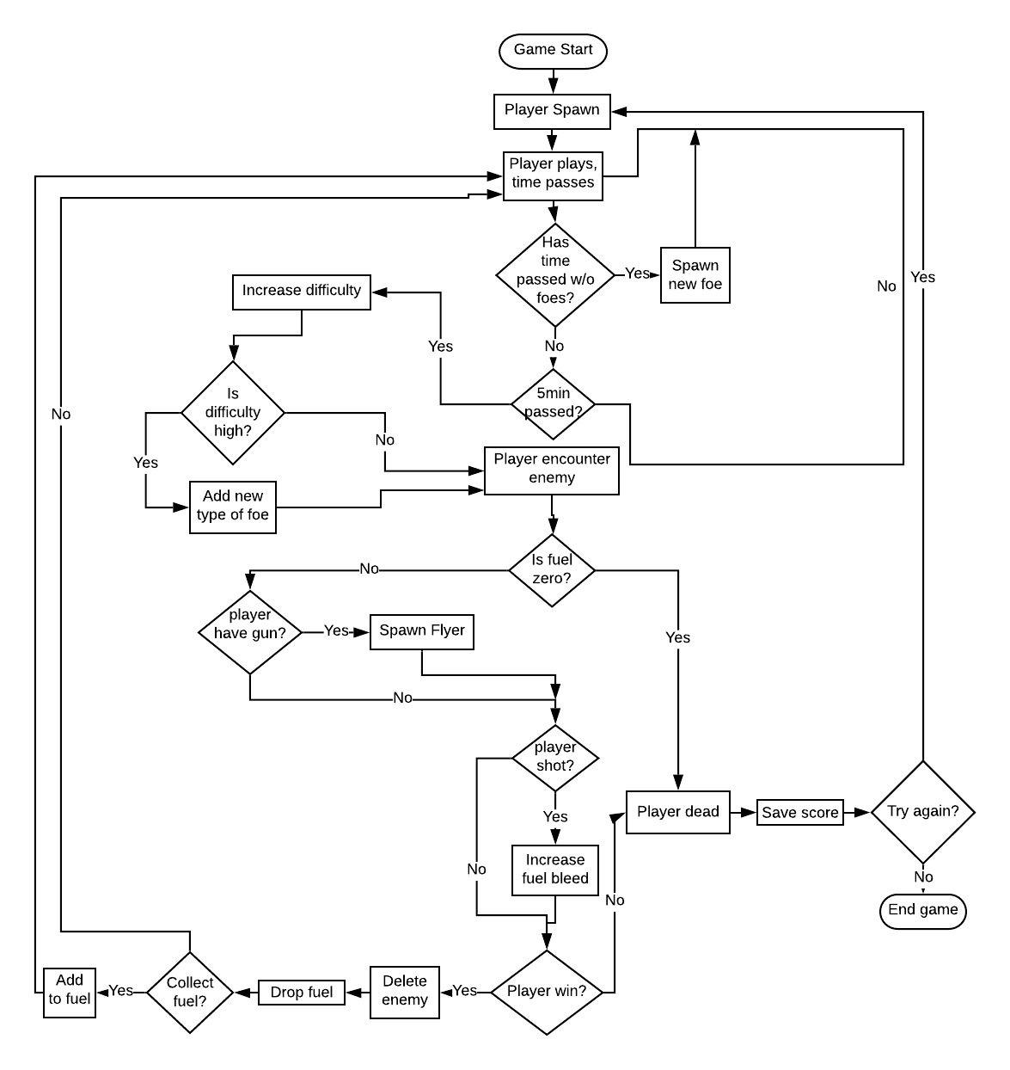

# Interface

## Menu

The main menu of the game will show the player four options: Play, Tutorial, Options and Quit. The menu’s background will feature an infinite scroll with the game’s logo and menu buttons fixed in place.

## Hud

The heads-up display will contain a score counter, a fuel tank, whatever weapon the player is holding and a hazard light symbol – the hazard light will flicker and slowly become more and more red as time passes and the threat the player faces becomes too much to handle.

## camera

The camera will be centred on the players car and follow them as the traverse the arena. It will be set at an angle to show the 3d models but not so much the player can see the sky.

# Team

Andrew Scott – Programmer, coordinator

Tembani Mdaya – Lead artist, composer

Thomas Riches – Programmer, designer

# Appendices

## Ammendments

Fixed AI, now follows player properly by using a navmesh agent

Changed map design to squared-off arena with ship landmark in centre.

## asset list